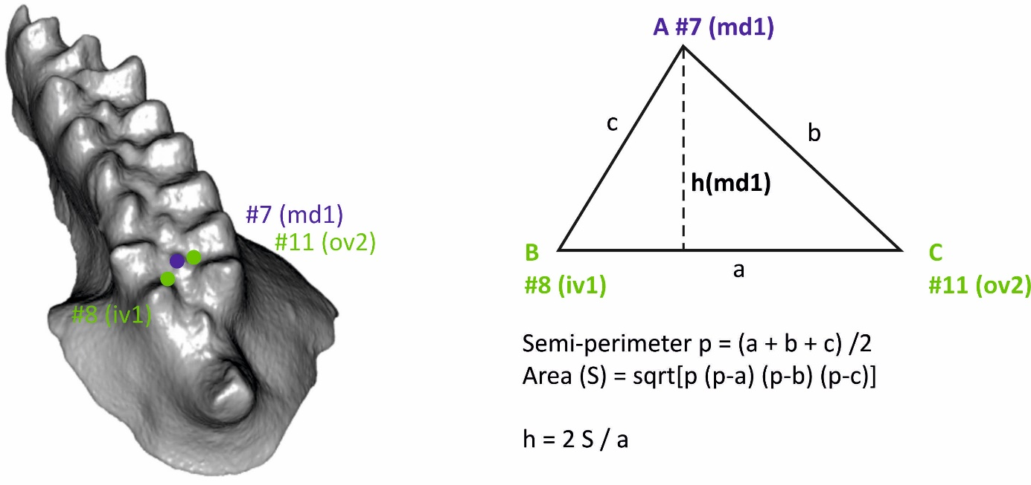
Supplementary Figure 1. Illustration of the calculation of md1 height by the geometry of the triangle iv1-md1-ov2.

